1. Insert, into an empty binary search tree, entries with keys 30, 40, 24, 58, 48, 26, 25 (in this order). Draw the tree after each insertion.

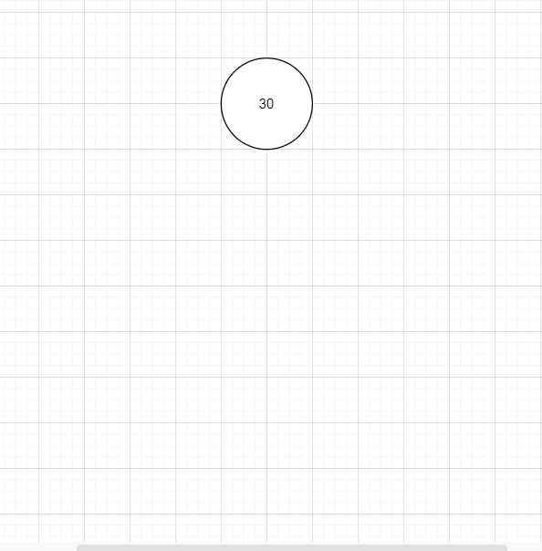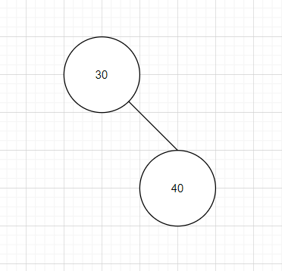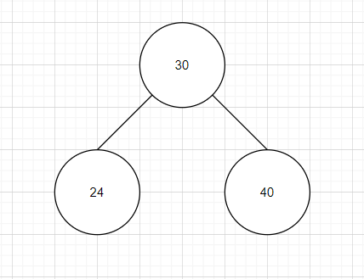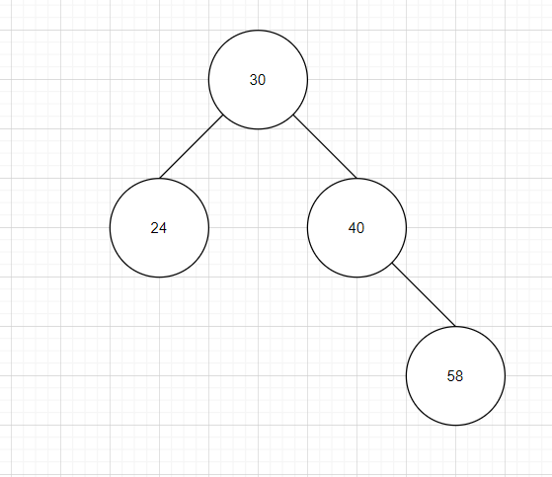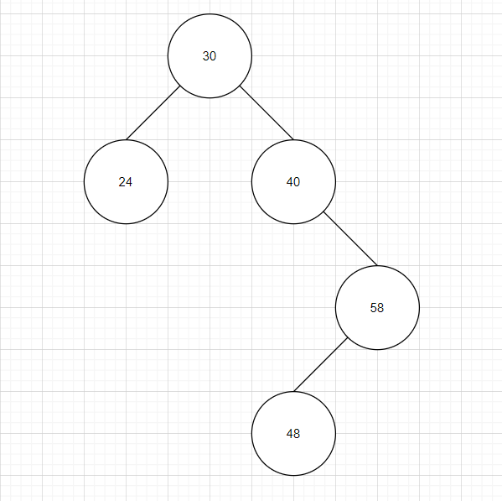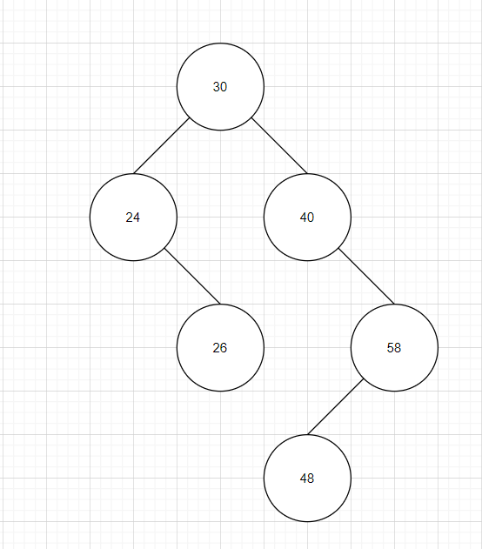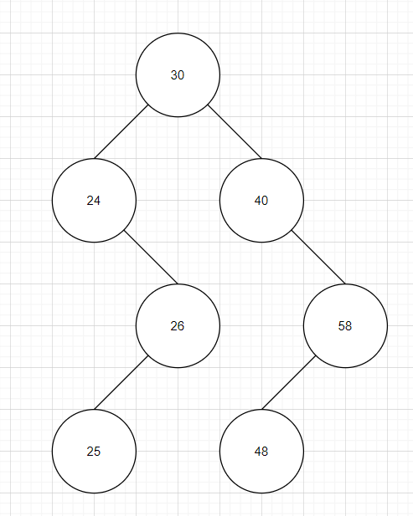

1. How many different binary search trees can store the keys {1,2,3}? 5
2. Draw an AVL tree resulting from the insertion of an entry with key 52 into the AVL tree

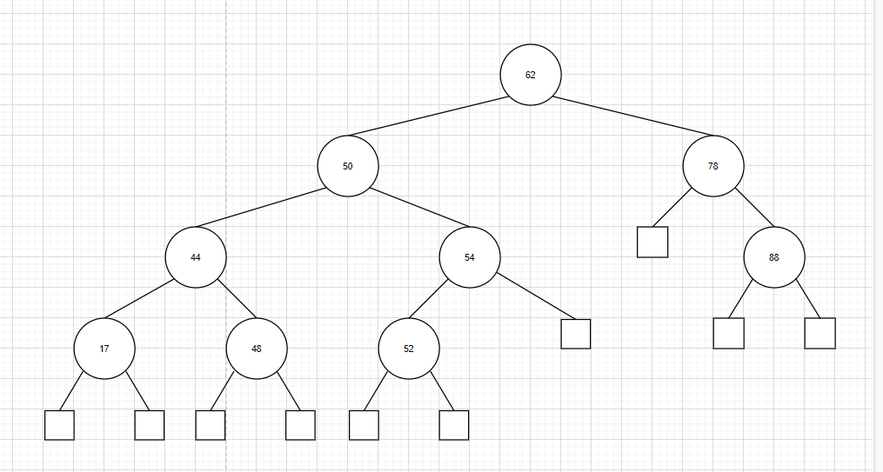

1. Consider the set of keys K = {1, 2, 3, 4, 5, 6, 7, 8, 9, 10, 11, 12, 13, 14, 15}. Draw a (2, 4) tree storing K as its keys using the fewest number of nodes.

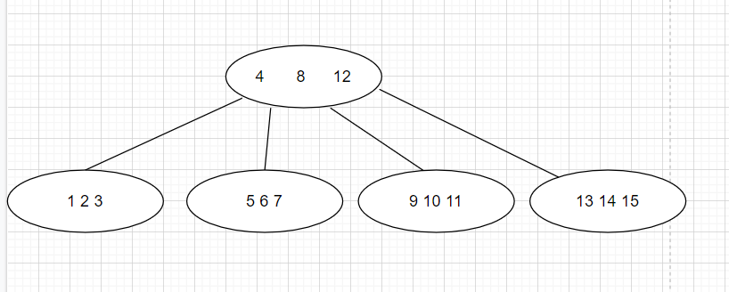

1. Insert into an empty (2, 4) tree, entries with keys 5, 16, 22, 45, 2, 10, 18, 30, 50, 12, 1 (in this order). Draw the tree after each insertion

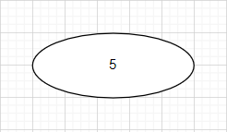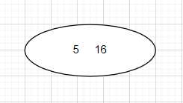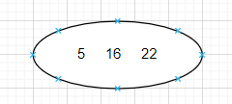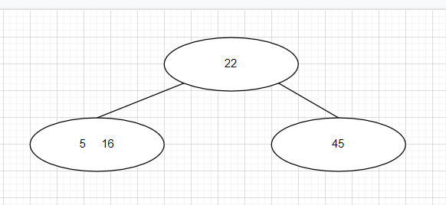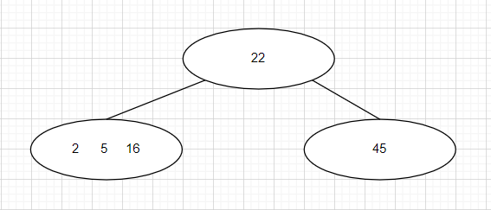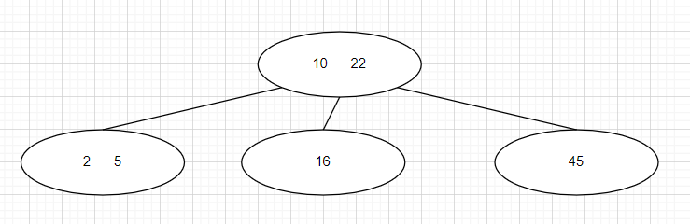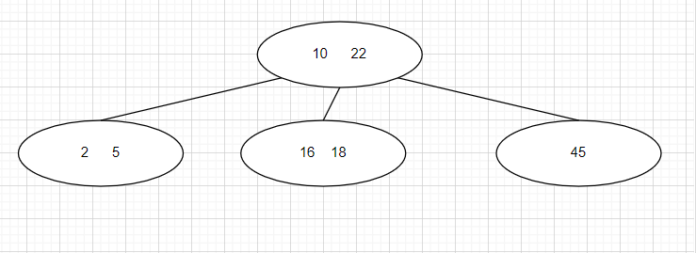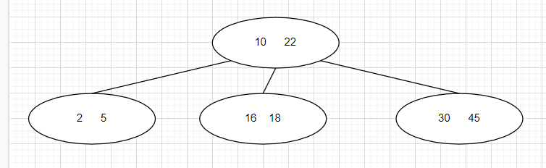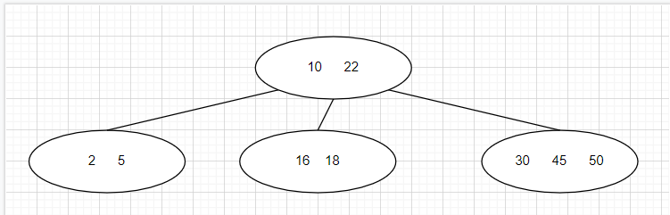

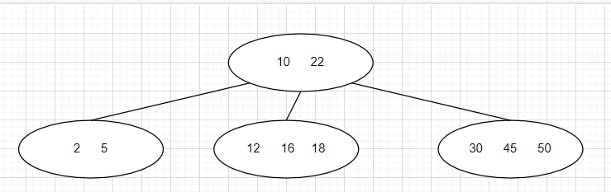

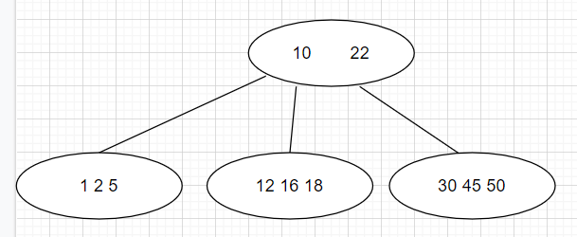

1. Insert into an empty splay tree entries with keys 10, 16, 12, 14, 13 (in this order). Draw the tree after each insertion

